Kamaal Bartlett

Guided Capstone Project

Big Mountain Resort

What can Big Mountain Ski Resort do to keep itself in position as a top-tier ski resort above its competitors while also maintaining high-profit margins and lowering costs?

In order to answer this question, we must first look at a dataset that includes all ski resorts in North America. The dataset provided by HR (change) includes key data for every ski resort in North America, along with Big Mountain Ski Resort. This dataset allowed us to get a deeper understanding of the metrics that mattered most and to identify the areas that were not worth the investment. In the beginning stages, we explored the data looking for completeness and accuracy. The data was compared and tested against the websites of a few ski resorts, and the information appeared to be accurate; this meant that the results being returned from any test run should be credible as the data matched. Through exploring the data, a few things stood out, not every resort offered the same amenities, and some resort’s data was mistyped, leading to large outliers in the data. In order to perform a more trustworthy analysis, the data had to be manipulated to a point where it could be used to make accurate predictions. First, we decided what columns should be dropped and what should be kept. If too many resorts were missing data for a column, it was dropped completely from the data set, as any analysis performed on it wouldn’t provide the results we needed. Next, the data was checked for mistyped inputs; anything that stood out too much compared to the other resorts was reviewed, and in doing this, at least the resort was found to have a date format that didn’t match, which skewed the data. These little adjustments helped change the bell curve’s shape when running the data through simple tables to compare the figures. Once the data was cleaned and ready for processing, we then went through the dataset and tried to pick out key factors and data that correlated and matched our end goal. One of the key data points we settled on was Adult Weekend prices and Adult Ticket Prices; both of these numbers would tell how much a resort is able to charge, which could then be compared to the number of tickets it sells, what amenities it offers and the location it is in. The price of tickets would become a baseline for the entire analysis going forward. Unfortunately, it was discovered early on that Adult Ticket Prices had more missing data than Adult Weekend prices. Therefore, Adult Ticket Prices had to be dropped from the analysis.

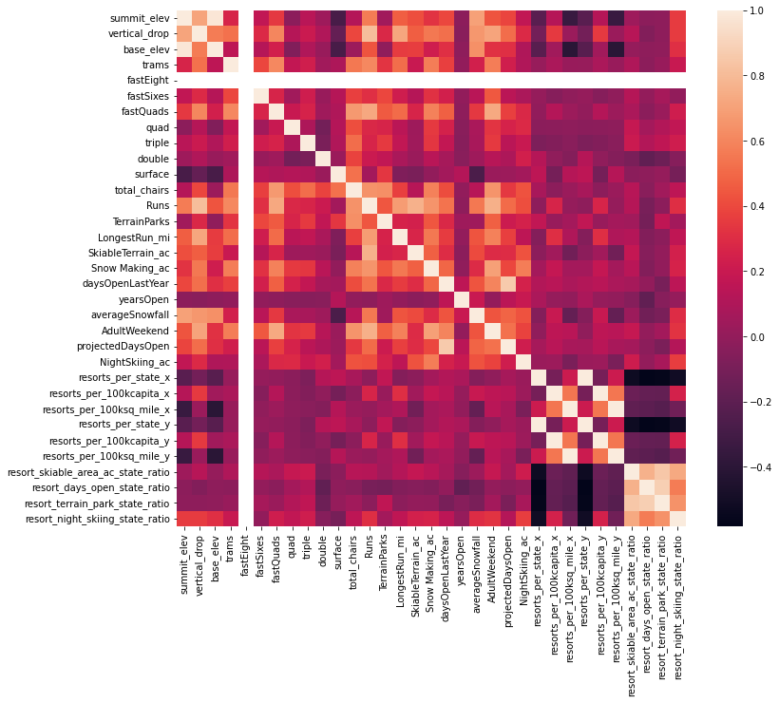

The table above is a heatmap that shows the correlation between two data points. This is the basis for the analysis going forward, as the items that are most closely correlated with ticket prices will be looked at further. While this decision was necessary, I believe added a limitation to the analysis as there was only one price point to compare various metrics to now instead of two. As the analysis continued on, features were built into the data set. A new data set containing information on US cities/states were explored and edited to fit the goal for the model, then both datasets were merged to create a dataset ready for modeling. But first, features were built into the dataset, important items that we thought would help the analysis, such as resorts per 100k sq miles and resorts per 100k capita.

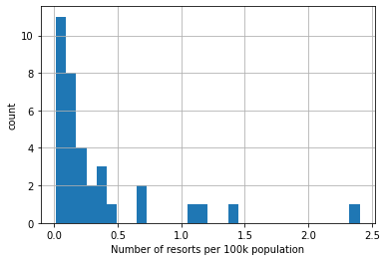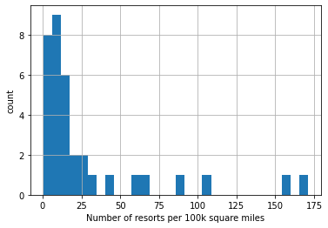

These new features were added to the analysis as we were able to not only look at the broad items in the data but also use those existing factors to create more in-depth data points for evaluation. After deciding on which data points would be key, adding in features, and merging the two datasets into one big set, it was time to start training the model. A test model was split out from the data, and we began training it and cross-validating the data. The results were a little surprising, but they also gave us confidence in Big Mountain Resort’s ability to increase profitability. Based on the findings from the binary tree and the pipeline built, Big Mountain Resort was undercharging for its tickets while offering some of the best amenities around. We also found that Big Mountain Resort should be able to increase ticket prices by almost $15 per ticket and still maintain the same level of customer retention. The executives of Big Mountain presented four scenarios that we were to test:

1. Permanently closing down up to 10 of the least used runs. This doesn't impact any other resort statistics.

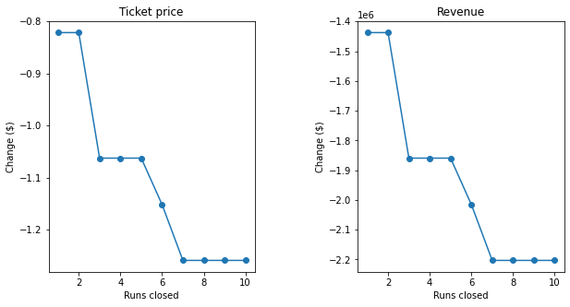

The graphs above show the revenue and ticket price drop-off as the number of chair lifts are lowered at the resort.

1. Increase the vertical drop by adding a run to a point 150 feet lower down but requiring the installation of an additional chair lift to bring skiers back up, without additional snow making coverage
2. Same as number 2, but adding 2 acres of snow making cover
3. Increase the longest run by 0.2 mile to boast 3.5 miles length, requiring an additional snow making coverage of 4 acres

After running these scenarios through the built model, it was determined that scenarios 1 and 2 were the only real viable options, as scenarios 3 and 4 didn’t add any real value to the resort and just weren’t worth the effort. Scenario 2 was the ultimate winner as the reward was so vast compared to scenario 1. Scenario 1 would result in little to no drop in revenue depending on how many chair lifts were put out of service, which would cut costs over time but not increase revenue. Based on the results from our model, Big Mountain Ski Resort had been undercharging for tickets, so it was imperative that we go with a scenario to help increase revenue and justify a rise in ticket prices. For that reason, we picked scenario 2 as it made the most sense overall. By increasing the ticket price from $81 to about $93 and assuming 350,000 guests visited in a season, Big Mountain Ski Resort would increase revenue from 28,350,000 to 32,550,000. The cost of a new lift is only 1,540,000, which would be offset by the new revenue amount. Raising the cost of the ticket after increasing the vertical drop and installing an additional chair, customers wouldn’t mind paying the new premium price as they can see the improvements made. It would be easier to justify a price increase followed by improvements as opposed to simply putting chairs out of service or even increasing the price without adding anything to the resort.

This analysis was built in a way that it can be reused in the future. Version control has been performed on the trained models, and they can be used to test against and validate future data as it comes in. Therefore, Big Mountain Resort workers should be able to duplicate these results in the future with refreshed datasets and come to new conclusions. I also believe that as the code is refined, it will become more user-friendly, so any business analyst can open the notebook and make meaningful conclusions.